How to remove the computer from tablet mode

If the computer has no icons on the desktop or looks like this: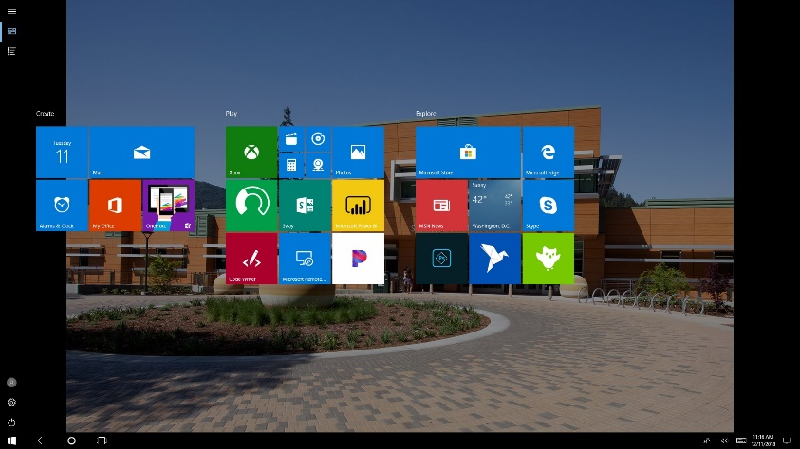
The computer is in in Tablet Mode.
Here’s how to turn it off.
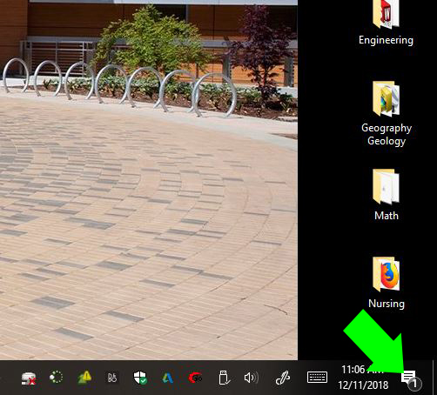
- Click on the notifications on the lower right hand of the screen:
2.Once the menu appears click on the tablet mode button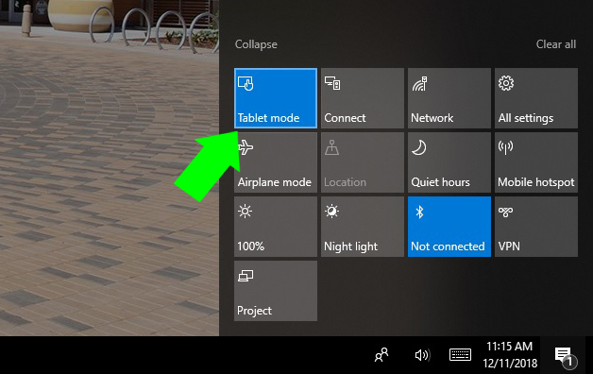
It should now be gray:
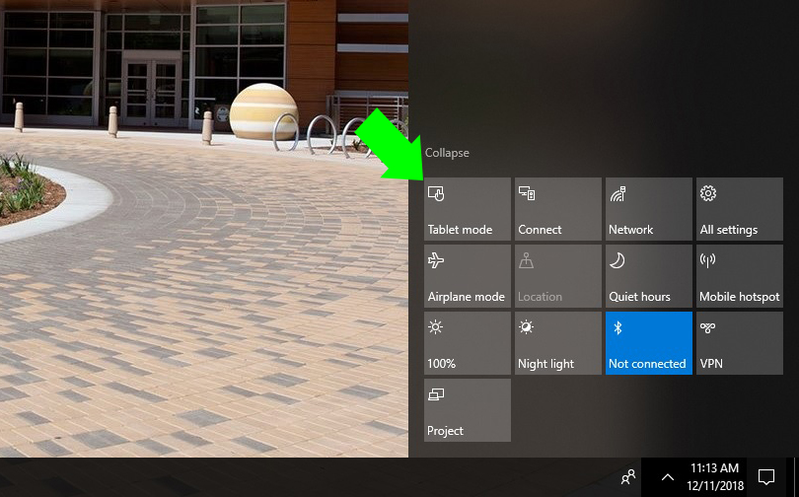
When you go back to the desktop the Icons should return: