Power point Viewing options
- To display or not to display your notes. Also known as see the slide on both screens: 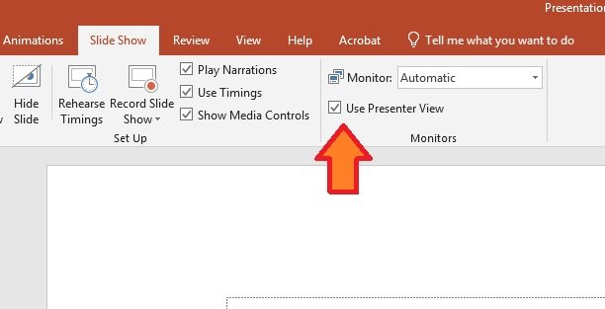
The option that affects this is the presenter view box under Slide show. If it is checked, the presentation will go into the mode in which one screen shows your notes and one screen shows the slide. If it unchecked the presentation will show the slide on both screens.
- When in presenter mode to change what screen, monitor or projectorwill have the slide on it, You can use the monitor control: 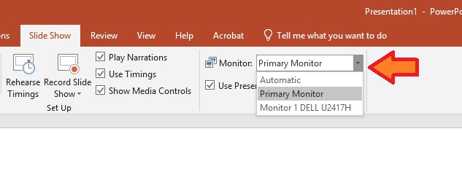
The Automatic should show the slide on the projector, but if it doesn’t you can click under the slide show tab where it says automatic next to where it says monitor and manually choose where you want the slide to display.

- To get the notes view the computer must be in extended mode vs. duplicate. Normally with the presenter view checked the computer will automatically go into this mode. If it doesn’t here are instructions:

To display a different image on the monitor and the LCD screen, press
The windows button:
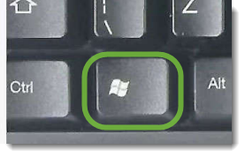+P button
When this window appears
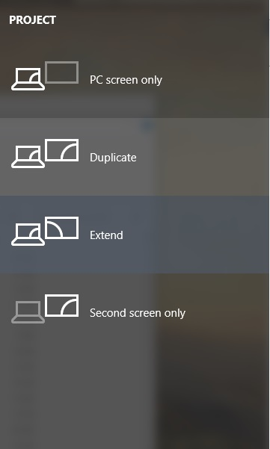
Choose Extended

